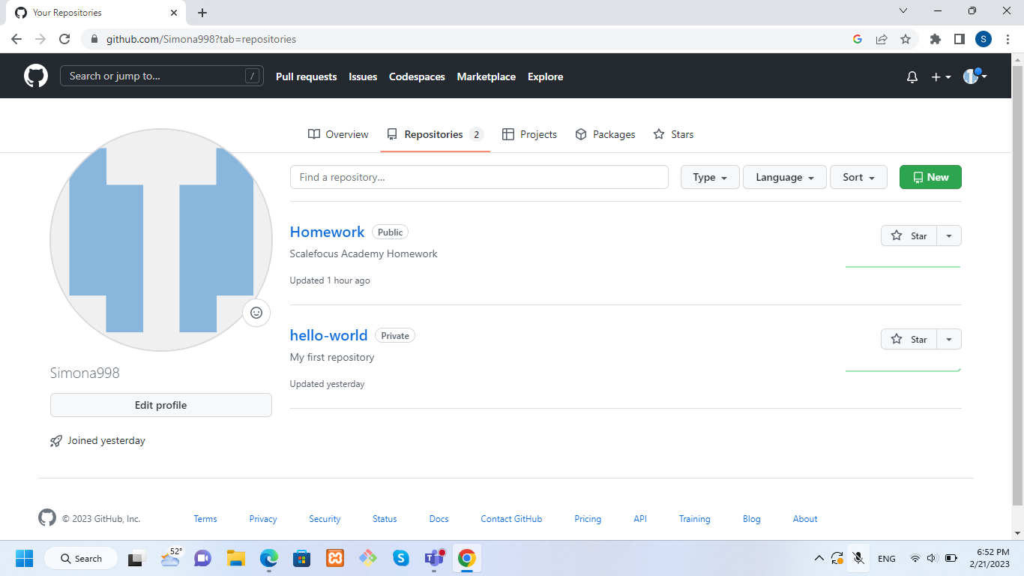

In this picture we can see the created hello-world repository

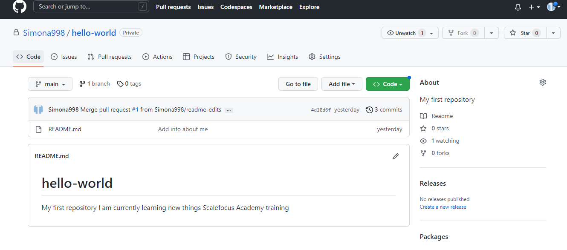

Inside this repository we can find README file which is edited. I have also created new branch, then pull request and merge pull request to merge the changes into main.

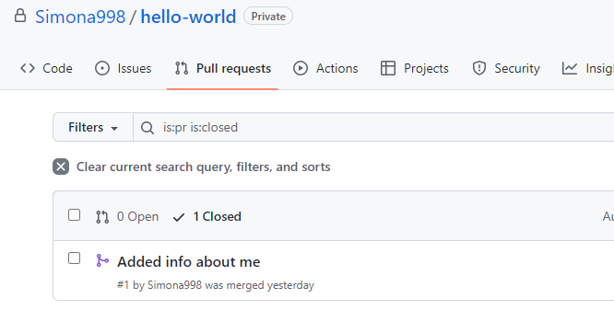

After merge I have deleted the branch I have created